Curriculum Vitae

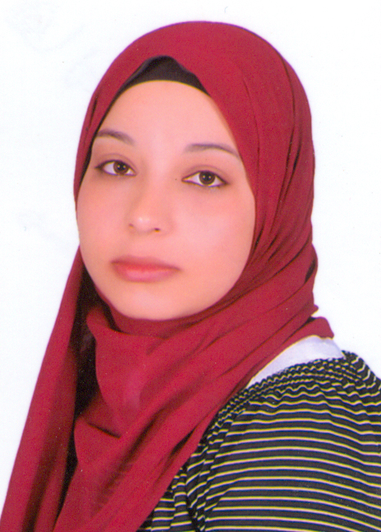
Name: Hala Abdelaal Mohammed
Date of Birth: 1/12/1995
Gender: Female
Religion: Muslim
Nationality: Egyptian
Address: Sohag, Egypt.
Contact Address: Department of Biochemistry, Faculty of Pharmacy, Assiut University
E-mail: hala.abdelaal1295@gmail.com
halamohamed11@pharm.aun.edu.eg
Phone number: 01551429551
Language: English, Arabic
Academic Qualifications:
- Bachelor in Pharmacy, Faculty of Pharmacy, Assiut University in 2019. Excellence with honor
- Demonstrator at Biochemistry Department, Faculty of Pharmacy, Assiut University.
Grade:
Demonstrator at Biochemistry Department Faculty of Pharmacy, Assiut University.
Computer Skills:
1- Microsoft Office.
2- Molecular Operating Environment.
3- Chemdraw

